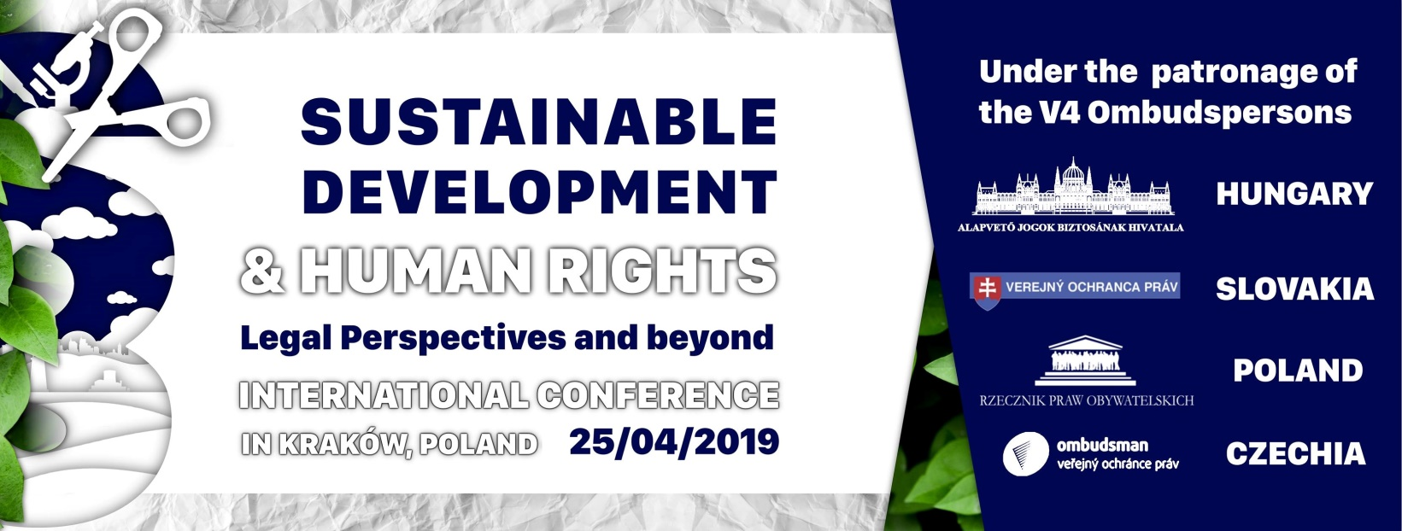

PROGRAM OF THE CONFERENCE

Conference venue: Representative Rooms, Larisch Palace, 12 Bracka Str.

9:30 Opening: prof. Barbara Iwańska Deputy Dean of the Faculty of Law and Administration, Head of the Chair of Environmental Law, Jagiellonian University in Krakow

9:40 Opening speeches
Sustainable development and human rights
Prof. Mária Patakyová, Public Defender of Rights, Slovakia
Dr. Adam Bodnar, Commissioner for Human Rights, Poland
Dr. Anna Šabatová, Public Defender of Rights, Czechia,
Dr. Gyula Bándi Ombudsman for the Future Generations, Hungary
Dr. hab. Adrienne Körmendy, Consul General, Hungary
Dr. Tomáš Kašaj, Consul General, Slovakia
Prof. Krzysztof Skotnicki, Honorary Consul, Czechia

10:40-12:10 Session 1 (chair: Ombudsman for the Future Generations of Hungary, dr. Gyula Bándi)
Evolution of the concept of sustainable development in legal and non-legal considerations
Anthropological vision of sustainable development – is legal subjectivity of future generations an expression of solidarity with them?
Maksymilian Sitarski (University of Warsaw)
Human Rights and Sustainable Development Goals
Gabriella Szamek (Eötvös Loránd University Faculty of Law)
Why gender equality is even a sustainable development goal
Klaudia Kinastowska (University of Warsaw)
Sustainable development in the Polish Constitution – the origins
Jakub Brejdak (University of Warsaw, Warsaw School of Economics)
12:10-12:30 Coffee break
12:30-14:00 Session 2 (chair: Commissioner for Human Rights of Poland, dr. Adam Bodnar)
Sustainable economy and rights of subjects involved in the economic relations
Tutaj wpisać temat z abstraktu PS
Paweł Słup (University of Warsaw)
What after Brexit? Concerns about sustainability of UK trade and investment policy
Cyprian Liske (Jagiellonian University in Krakow)
The regulation of financial market as a way of realization of sustainable development
Jacek Mainardi (University of Warsaw, Warsaw School of Economics)
Industrial organization and sustainable development of economy
Filip Lubiński (University of Warsaw, Warsaw School of Economics)

14:00-15:00 Lunch break
15:00-16:30 Session 3 (chair: prof. Barbara Iwańska)
Environmental rights, responsibilities and prohibitions
Right to water and sanitation – is it still a great challenge for the European Union?
Vivien Benda (Pázmány Péter Catholic University)
The birth and foundation of the ‘polluter pays’ principle
Arthur Champeroux (Unversité Montesquieu Bordeaux IV)
Should the countries’ responsibility to diminish food waste be achieved through implementing law?
Katarzyna Pelc (Jagiellonian University in Krakow)
Actions taken by oil companies - opportunity or threat for sustainable developement?
Marcin Kamiński (University of Warsaw)

16:30-16:45 Coffee break
16:45-18:15 Session 4 (chair: Public Defender of Rights of Slovakia, prof. Mária Patakyová)
Legal and non-legal challenges to achieve sustainable development
Designing lives. Legal aspects of genetic engineering in the light of sustainable development
Lena Helińska (Jagiellonian University in Krakow)
Harnessing technology and innovation to achieve the sustainable development goals. Example of transposition of the EU directive on the deployment of alternative fuels infrastructure into Polish law
Monika Świderska (University of Warsaw)
Protection of the right to clean air under the provisions of Polish civil law
Monika Bagier (Jagiellonian University in Krakow)
The new Chinese civil code and its contribution to the sustainable development
Igor Szpotakowski (Jagiellonian University in Krakow)

18:15 Conclusions & Closing

The conference is organised by :
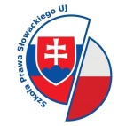
School of Slovak Law
Coordination Center for Foreign Law Schools (Jagiellonian University in Krakow)

